Support your child

(taken from https://eal.britishcouncil.org/parents/support-your-child The British Council, last accessed 11.11.14)
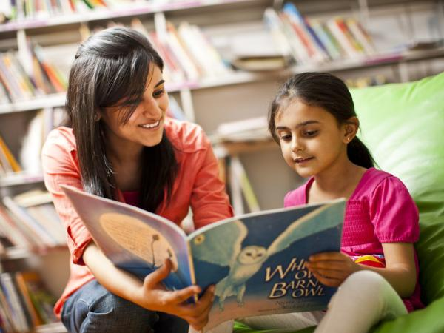
On these pages, there is information about how best to support your children, whether they are new to the school or are progressing through the education system. Some of the important ways you can do this are:
- speaking in your first language at home
- getting involved in schools
- supporting your child with homework.
Parents are a child’s first and most important teacher and this influence continues throughout a child’s learning journey. We know from research that where parents are involved with their child’s learning, there is a positive impact.
Learning at home is very important to the progress and development of all children and schools value the contributions parents make.

How can I help my child if I am not fluent in English?
The quality of talk in the home is one of the key factors in enhancing learning and this can take place in any language. Parents do not have to speak good English to support children. You can help by:
- showing an interest in your child’s learning
- building on your child’s natural curiosity and fascinations
- asking them to tell you about what they have been learning at school
- praising your child for positive learning attitudes and persistence
- building your child’s self-esteem and belief that they can achieve
- encouraging your child to have high aspirations
- encouraging your child to find out more about a topic by asking relatives, using the library or searching on the internet

Speaking in your home language

(Taken from https://eal.britishcouncil.org/parents/speaking-your-home-language The British Council, last accessed 11.11.14)
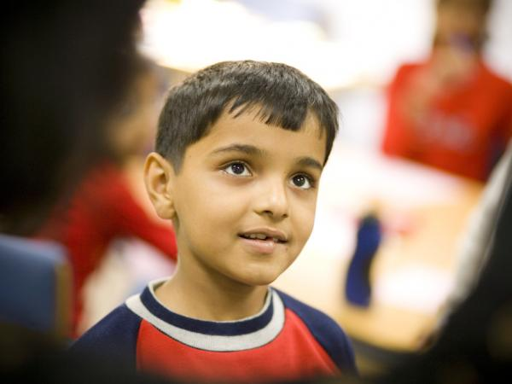
It is very important for children and young people learning English as an additional language to continue to use their first language at home because this is the language your child can speak confidently. First languages are special, and can help families share their values and traditions and cultural identity. If children and young people keep using their first language they can join in with family and community events and keep in touch with relatives, including grandparents and cousins who may live in other places.
In addition, children who can speak another language can also learn English better because they see when words are similar (or have a similar meaning) and can also use what they know about grammar in their first language to help them work out English grammar. This also makes it easier to learn other (new) languages at school.
Being fluent (able to say everything easily) in two or more languages helps children make more friends and understand different cultures. It also improves thinking skills. If you can speak, read and write in more than one language it can help you find a job when you leave school. Many employers like people who are good at languages.

How can I support my child in first language learning?
There are easy ways you can help by:
- singing songs, telling stories and sharing books in your first language
- telling jokes, learning rhymes and having fun with language
- watching television programmes or DVDs and talking about them
- talking together at meal times
- staying in touch with family and friends by talking together on Skype or writing emails
- buying or borrowing dual (2) language books from the library for your child to read.

What if my child refuses to speak our first language at home?
Sometimes it can become difficult to keep talking in the first language, particularly when children and young people prefer to use English. Some children begin to feel self-conscious or uncomfortable about using their first language, especially outside the home. Teenagers may want to speak English so that they feel accepted by friends at school. Your school will want to respect and value your first language and it is important for children and young people to feel proud of their language and culture. Explaining the importance of being bilingual may help. Keep speaking to your child in their first language and in English if they want, it will help them use both.

Can my child gain qualifications in their first language?
If secondary school children already have good reading and writing skills in their first language, it may be possible to get language qualifications but this depends on which qualifications are available in your child’s first language. Ask at your child’s school to find out if this is possible. You may also be able to get qualifications at a supplementary or community school (see below). In rural areas where learners are isolated, pupils may have to do extra study at home for these exams. Many students do very well in first language exams and this gives them a lot of confidence.
You can get more information from exam board websites or at your child’s school. You can also visit AQA languages and Edexcel Qualifications.

Supplementary and community schools
To support children’s first language learning even more, you should ask people in your community, at your child’s school or at your local library about supplementary schools.
Classes are usually held in the evenings or at weekends where children and young people can meet and develop first language literacy skills as well as learning about culture and heritage and/or faith. Some supplementary schools also provide support for national tests and GCSE examinations.

Getting involved in schools

(taken from https://eal.britishcouncil.org/parents/getting-involved-schools The British Council, last accessed 11.11.14)
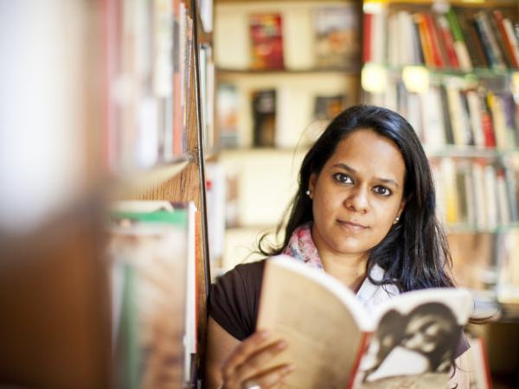
Schools in the UK want to involve parents in school life and will try to share information and include families who speak little English. Schools here believe education involves the parents (or carers) and the school working together to help children learn.

How do I find out more information about my child’s school?
When your child starts school, school staff will help them settle in and support them to make friends and join in lessons and other activities. Parents can also support their children to feel happy and part of the school by understanding how the school works. (See School life for more information)
For example you will need to:
- provide school uniform and PE kit
- support good attendance and behaviour
- make sure your child does their homework
- attend parents meetings and school events.

What equipment do I need to buy for my child?
To make a good start, you need to buy some school equipment such as pens and pencils. It is a good idea to ask the school what you need to buy when you attend the admission interview.
Most secondary schools and some primary school require children to follow a dress code or wear a uniform. This includes a PE kit (clothes for sports). You may have to buy the uniform from a special shop or directly from the school. Ask the school if you need help with payment as grants may be available.

Will I have to pay for school meals?
School meals are free for some children (such as Key Stage 1 in England) and will consist of a midday meal of healthy food. Special dietary needs are catered for. Families who receive benefits can claim free school meals for older children. Please ask the school for an application form if you think you are eligible. Families are welcome to supply a healthy packed lunch for children to eat instead of the school dinner.

Can my child take time off school for religious holidays and visits to relatives?
Your child must attend school regularly and all schools ask parents to contact the school when their child is absent. You may need to send a letter giving the reason for absence when your child returns to school. Illness and medical appointments are ‘authorised absences’.
Your child can take a day off school for religious holidays, but other reasons such as family visits are ‘unauthorised absences’. Extended visits to another country must be taken during school holidays.
If your child has to miss school because of an emergency, please tell the head teacher as soon as possible. If you would like to know more about attendance, please ask at the school office or check the school’s website.

How can I become more involved with school life?
Schools want to build good relationships with parents and want parents to be involved in school life by:
- attending parents’ meetings or consultations
- joining celebrations, concerts and assemblies
- volunteering to help in school
- becoming part of the parent fundraising association.
Although you may lack confidence in speaking English at first, please do not worry. The first step is to accept friendly approaches from other parents and school staff. There may also be school staff who speak your language and can interpret for you.
Try and develop good communication from home to school and from school to home. Talk to your child’s teacher in the playground after school and share your hopes and dreams for your child as well as any worries.
It can be more difficult for parents of older children to stay in contact with teachers. Secondary schools often give pupils a diary to record their homework. There will be space for teachers and parents to write notes to ask questions or raise concerns. Nowadays many schools use email or texts to share information with parents. Ask for the parent password.
If your child is unhappy or is being bullied you need to tell the school so that staff can take action to keep your child safe and happy. (See also Your child’s rights). If you want to share any personal or confidential information with the school and prefer to use your own language, please ask for an official interpreter.
Sometimes you will be too busy to make face-to-face contact with teachers, but you can still find out what is happening in school in other ways. School websites are full of information and you can translate pages into your first language with ‘Google Translate’. You will usually find links to other websites that can help your child’s learning such as BBC Bitesize
When you collect your children from school you could look at classroom displays and find out what topics they are doing. There may be a notice board which tells you about after-school clubs for children, for example football, music or language clubs. Sometime there is a before-school breakfast club.

How will the school contact me?
Schools usually communicate with parents by letter, email or text. Please make sure the school has your contact details so that they can find you quickly in an emergency. If you cannot understand the information, ask for a translation or an interpreter. Schools want to find out how to improve access and equality for all parents. If you would like to contribute to the decision-making processes of the school please enquire about becoming a school governor.

Where else can I go to support my child’s education?
The local library is a good place to look for learning in the community. Library membership of the library is free, but you will need to take proof of your name and address on an official document. In the library you will find:
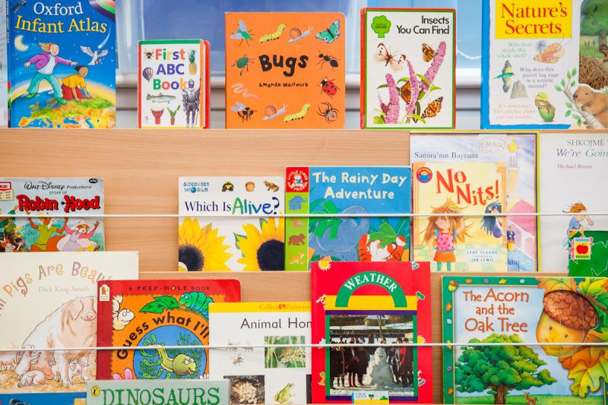
- books, audio books and DVDs to borrow
- some books and newspapers in other languages
- a wide range of children’s books
- computers with internet access
- newspapers and magazines to read
- information about supplementary schools, community groups and places of worship
- information about adult learning classes e.g. ESOL (English for speakers of other languages).
Some libraries offer free storytelling sessions for young children and reading groups or homework clubs for older ones. The library should able to give you.

Other places for learning
For people who live in cities, national museums and art galleries offer exhibitions and events for all ages. Most towns also have a local history museum. You will also find leisure centres with sports facilities and swimming pools. Swimming lessons are available for children, young people and adults. Local parks usually have children’s playgrounds and some have tennis courts, football pitches and other sports facilities. Most of these facilities are free and by joining in some of the activities you and your children will meet other people, make friends and learn English quickly.

Young children
If you have young children, visit the local Children’s Centre where you can access early learning and childcare and find out about health services for children and young babies. All children are entitled to some free nursery education after age three.

Supporting your child with homework

(taken from: https://eal.britishcouncil.org/parents/supporting-your-child-homework The British Council, last accessed 11.11.14)
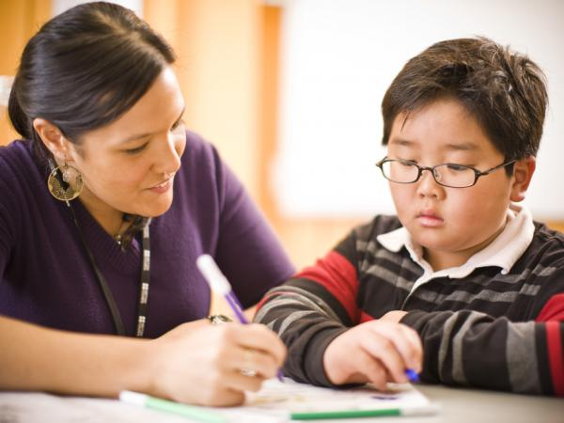
Many schools expect that parents will share books with children from the very start of full-time school. Getting into a routine of reading at home is helpful and sets a pattern, showing how important good literacy skills are.

Reading together
Your child may not be ready to read the words but it’s just as important to talk about the pictures and the story. You can do this in your home language, helping your child to understand what is happening in the story. Some schools also have home language books or dual language books to use at home. Show your child the print and read together in your home language or English. Let them read the words they want to and tell them if they ask you what the words say. Enjoy reading books: make it fun, a special time for being together.
If you want to learn more about how reading is taught, talk to the school. Some schools have reading workshops for parents or they let parents come into the classroom to see how they do things.

Homework at primary school
As young children move through the early years or infants classes (normally 4, 5, 6 or 7 year olds), the school may send home something for you to do together. Children may be asked to find photos or other objects at home that can be shared in school. There may be opportunities for parents to visit the class and to help with class outings. The more you can help with the learning of your child, the better your child will do at school.
In the older primary or junior classes (normally 7, 8, 9, 10 or 11 years olds), most schools ask that parents continue to read with their child at home and to help them with homework, for example, some extra work in English, Maths or Science. In the last year of primary school, doing homework is seen as good preparation for secondary school.

Homework time
It is important to get the balance right. Children should not be spending too much time on homework but they should not be only spending a few minutes on it. You can help your child understand why homework is important and use your first language to explain and support. Praise your child when they have done something well and put on show any certificates or stickers they receive from school for good work, behaviour or attendance. If you have any worries, speak to school staff.

Homework at secondary school
At secondary school homework is usually set following a weekly timetable. Young people at secondary school are expected to work more independently (on their own) than at primary school. Homework tasks may include finishing work started in class or doing extra work like researching information about the topic being studied. The homework policy and topics being studied each term are often on the school website. Parents can help by:
- making sure your child has a quiet time and space to study
- giving them the resources needed: e.g. pens and paper, computer, English dictionary, bilingual dictionary or internet access
- helping them to get into a regular routine
- making sure they are spending the right amount of time on homework (this could be from 45 minutes when they are younger and about 2 hours when they are older)
- talking to them about their learning in your first language
- helping them research the internet for first language resources on topics being studied
- asking if there is anything you can do to help
- helping them organise their time well
- giving them support and encouragement
- reminding them to ask the teacher for help: e.g. borrowing text books, keywords lists, written examples or models
- encouraging them to go to any study, homework and revision clubs run by the school
- talking to their form tutor or subject teacher
- finding resources in the local community (e.g. public library, internet access or homework clubs)
- if you are planning a day out, visit a museum, gallery or other place of interest that links with the topic your child is studying
- reading a good range of books, websites and news stories at home.

Your child’s rights

(taken from https://eal.britishcouncil.org/parents/your-childs-rights The British Council, last accessed 11.11.14)
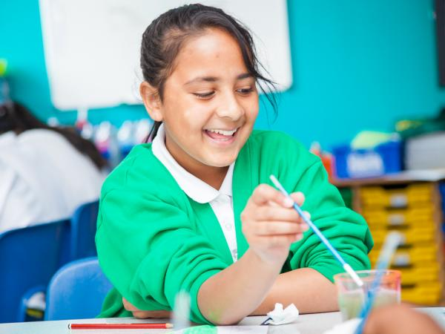
All children and young people in the UK have certain rights by law. There are several different types of laws that are especially relevant to the rights of children and young people:
- Laws about schools and education
- Equality laws
- The UN convention on the rights of the child

Schools and the law
There are a lot of laws about what schools must provide. Here are some of the main ones that affect your rights and your child’s rights.

Your child has a right to a school place.
Education is compulsory in the UK and all children and young people between the ages of 5 and 16 have a right to a school place. The local authority where you live must offer your child a school place (but if your local or chosen school is full, they may offer you a place somewhere else).
It is expected that you will send your child to school every day and on time unless they are ill. If your child does not attend school or you take your child on holiday during term time, you may be prosecuted and have to pay a fine.

Your child has a right to be protected from harm.
By law schools must protect children and young people from harm, for example:
- schools must protect children and young people from harm
- school staff must provide a safe environment where children and young people can learn
- schools must do something if they think a child or young person under the age of 18 is being harmed, abused or neglected.

You have a right to withdraw your child from assembly or religious education.
All schools must teach religious education (RE), which usually includes education about a range of religions and beliefs, and a daily assembly, which is usually expected to be mainly Christian (but may also include other faiths). Parents have a right to ask that their children do not go to assembly or RE lessons, or both. Young people over the age of 16 can decide not to attend assembly or RE themselves.
If you are worried that your child’s rights are not being properly considered you should talk about this to the school.

Equality laws
The Equality Act 2010 says that schools are not allowed to discriminate against children and young people (treat them differently or unfairly) because of their:
- disability
- gender
- race
- religion or belief
- sexual orientation
- or because they are pregnant or changing their gender.
This means that schools must not treat children or young people less favourably for any of these reasons. They must treat everyone fairly. This includes all parts of school life, for example:
- school places: for example a school cannot refuse to accept a young person because they are disabled
- teaching and learning: for example a school cannot stop a pupil studying a school subject because they are male or female
- out-of-school activities: for example a school cannot refuse to take a child on a trip because they are disabled
- bullying: for example schools must protect young people who are being bullied, including bullying that is about race, gender, sexual orientation or identity, religious faith or disability (Bullying is when someone hurts you either physically, by hitting or kicking you, or verbally, by calling you names or teasing you.)
- rewards and punishments: these must be fair to everyone.
Schools are also not allowed to treat children and young people differently because of their disability, gender, race, religion or belief, sexual orientation or gender identity.
By law, schools must:
- not treat pupils, parents, teachers or community members differently
- promote equality of opportunity and being fair to everyone
- encourage good relations between different groups of people.
The Equality Act 2010 does not only apply to schools. If you or your child is being discriminated against or upset by other people at work or in the community, that is also illegal. If you or your child are abused or attacked because of your race, religion or belief, disability, sexual orientation or because you are transgender, that is a hate crime and treated very seriously by the police.
- More information about equality laws can be found here
- If you have been the target of hate crime you can find support and further information here

The UN convention on the rights of the child
The UN convention on the rights of the child is an international agreement signed by almost all UN countries, including the UK. Under this convention everyone under the age of 18 has a lot of important rights, including:

The right to have their views respected (Article 12)
Every child has the right to say what they think in all matters affecting them, and to have their views taken seriously.

The right to freedom of expression (Article 13)
Every child must be free to say what they think and to seek and receive information of any kind as long as it is within the law.

The right to freedom of thought, belief and religion (Article 14)
Every child has the right to think and believe what they want and also to practise their religion, as long as they are not stopping other people from enjoying their rights.

The rights of refugee children (Article 22)
If a child is a refugee or seeking refuge, governments must ensure that they have the same rights as any other child.

The rights of disabled children (Article 23)
A disabled child has the right to live a full and decent life in conditions that promote dignity, independence and an active role in the community.

The right to education (Article 28)
Every child has the right to an education. Discipline in schools must respect children’s human dignity.

The goals of education (Article 29)
Education must develop every child’s personality, talents and abilities to the full. It must encourage the child’s respect for human rights, as well as respect for their parents’, their own and other cultures, and the environment.

The rights of children of minorities (Article 30)
Every child has the right to learn and use the language, customs and religion of their family, whether or not these are shared by the majority of the people in the country where they live, as long as they are not stopping other people from enjoying their rights.

