School life in Scotland

(taken from https://eal.britishcouncil.org/parents/school-life-scotland The British Council, last accessed 11.11.14)
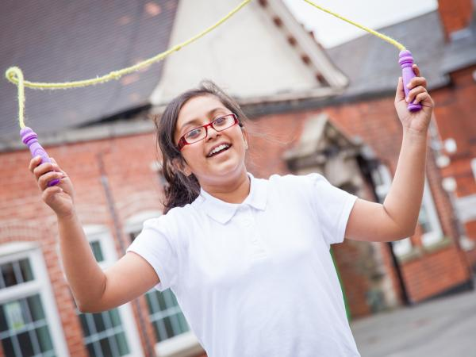
This page gives information to parents and carers about life at school, in particular about the timetable of a typical day in a primary school or in a secondary school, about the school subjects, physical education, school meals, school uniform, assembly and religious education, teaching and learning and key people in schools. We encourage you to visit schools and ask any questions or share your concerns about your child’s education.

Timetable of a typical day
Schools do not all have the same timetable, but most schools will follow a similar routine of a typical day at school.
In primary school
- Registration: first thing in the morning, as children arrive in their classroom, their teacher does the ‘register’ calling everyone’s name and checking that everybody has arrived at school on time. If someone is absent, the teacher will inform the school office.
- Assembly: meeting of teachers and children at a set time during the day. In some schools, this includes prayers and religious songs.
- Literacy (English)
- Numeracy (Maths)
- Morning break or playtime: children have a break and normally go outside to play
- Lunch break and playtime: children have a break to have their lunch and play
- Other subjects - see section on school subjects below
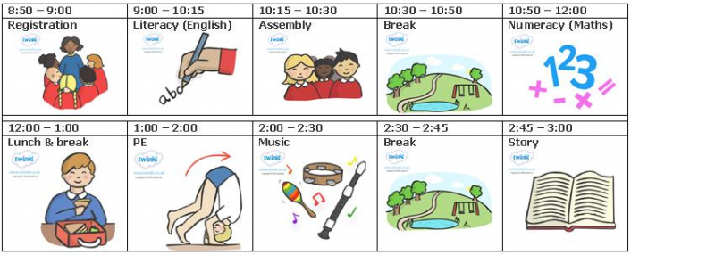
Example of a typical day in primary school

In secondary school
- Registration or tutor time: time when learners join their tutor group or form at the beginning of each school day to be registered and to receive important information OR
- Assembly: meeting of teachers and children at set times during the week. In some schools, this might include prayers and religious songs.
- Period (lesson) 1
- Period 2
- Morning break
- Period 3
- Period 4
- Lunch break
- Period 5
- Period 6
- Period 7
School subjects and Curriculum for Excellence
The curriculum comprises a broad general education up to the end of third year at secondary school (from age 3 to 15) followed by a senior phase of learning from fourth to sixth year which responds to individual needs and supports particular aptitudes and talents. The learners follow a broad range of subjects at schools, including:
- Maths (number, money and measure, shape, position and movement and information handling)
- English (listening and talking, reading, writing)
- Health and Well-being (mental and social well-being, physical well-being, physical education)
- Science (chemistry, physics and biology)
- Social Subjects (geography, history, modern studies)
- Religious and moral education
- Religious Education (in Roman Catholic schools)
- Technologies (includes ICT)
- Expressive arts (art, music, drama, dance)
- Modern foreign languages (French, German, Spanish or other languages)
The content of each subject is based on the Curriculum for Excellence. The curriculum aims to ensure that all children and young people in Scotland develop the knowledge, skills and attributes they will need if they are to flourish in life, learning and work, now and in the future.
Physical education (PE)
Boys and girls must take part in physical education both in primary and secondary schools. Most schools will ask your children to wear a PE kit, which is a set of clothes chosen by the school for this activity. It often includes wearing a T-shirt, shorts or jogging bottoms.
If you are worried about privacy when your child changes his or her clothes for PE, or whether the PE kit is culturally appropriate, please contact the school to discuss your worries.

School meals
Children have their lunch at school and can choose between having school dinner or packed lunch. School dinners are often freshly prepared in school and children can choose from a selection of healthy meals. Your child may be able to have free school meals, for example if are asylum seekers, receive job-seekers allowance, income support, employment and support allowance, etc.

School uniform
Children and young people wear a uniform in most primary and secondary schools. You can find information about the uniform from the school's website.
School uniform items, e.g. dresses, trousers, shirts and shoes, can be bought cheaply from most supermarkets.
Secondary school uniforms are similar to primary schools, but sometimes school blazers with the school logo on the pocket are also worn. Some schools are very strict about their uniform policies and others are more relaxed. Sometimes schools have second-hand uniforms available to buy, especially more expensive items like blazers.

Assembly and religious education
During assembly, there are often prayers or religious music, usually of Christian faith.
Your child will also attend a class of religious education (RE) on a weekly basis. RE should cover the main religious faiths. Some schools may spend a substantial amount of time on Christianity. You have got the right to ask that your child does not attend assembly and/or religious education. For more information, please visit the page on your rights.

Teaching and learning
The way teachers teach in Scotland might be different from the ways teachers might teach in other countries. For example:
- your child will be encouraged to take part in practical activities
- your child will sometimes be encouraged to interact and discuss things with other people during lessons, so sometimes it is quite noisy
- your child will be encouraged to share their knowledge and experiences to contribute to lessons
- your child will be encouraged to ask questions if they do not understand. This is valued and seen as a strength and an excellent attitude to learning
- your child will probably not be asked to learn facts by heart.

Key people in schools

In primary schools:
- Classroom teacher: the person who teaches your child on a daily basis. Occasionally, a class might have two teachers teaching on different days of the week
- Pupil Support Assistant (PSA): a person who assists a teacher in class
- Head teacher: the teacher in charge of a school
- Deputy head teacher: the teacher who is the main assistant of the head teacher
- Clerical Assistant: the person who works in the school office and is the main contact person for parents and visitors.
- Parent Council: group of people who represent all parents and carers in the school. They contribute to social events, fundraising in the school and recruitment of staff. The parent council can include representatives from staff, parents/carers and the community.

In secondary schools:
- Tutor/Registration teacher: the person who takes the register in the morning and will get to know your child well.
- Subject teachers: in secondary schools there are usually different teachers for each subject, e.g. Maths teachers, English teachers, Geography teachers, PE teachers, etc. Your child will probably have at least ten different subject teachers when you start secondary school.
- Pastoral Care teacher: the teacher who will look after your child's health and well-being in school and help your child plan for their future beyond school. Your child would speak to his/her pastoral care teacher if they are worried about anything in school or at home.
- Support for Learning Teacher: the teacher who can help your child when they need extra support for their learning.
- EAL teacher: teacher who supports learners who have English as an additional language to access the curriculum.
- Pupil Support Assistant (PSA): a person who assists a subject teacher in class
- Head of department/Faculty Head: each subject, e.g. Maths, Science, P.E, etc, will have a head of department who is in charge of the subject teachers. Some subjects may be grouped together into a faculty.
- Head teacher: the teacher in charge of a school
- Deputy head teachers: senior teachers who assist the Head teacher with the running of the school. Deputy head teachers also have responsibility for particular year groups and look after everything that happens to your child's year group in school.
- Clerical Assistant: someone who works in the school office and is the main contact person for parents and visitors.
- Parent Council: group of people who represent all the parents and carers of pupils at the school. They are consulted about school developments, contribute to events and fundraising and are involved in the recruitment of senior school staff.

