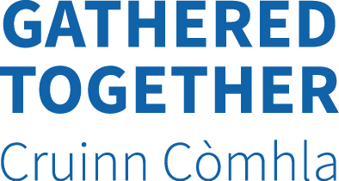

Bespoke Support Application
Name of school/ Parent Council

Size of school

Ethnic Minority population of school (nationality, % etc)

Number of EM parents on Parent Council

Why does your school/ PC want support from Gathered Together?

What do you hope to gain from GT’s support?

If successful when could GT come out for an initial meeting?

Please return this form to Richard.Bloodworth@bemis.org.uk by 14 September 2015

